CO2 – Assessment 02 24 – 10 – 2026
SCENARIO BASED
Course code: DSA0308
Course Name: Natural Language Processing
Reg No: 192324300 Harisha S

Question 1
Morphological Parsing and Normalization Using Python
Title:
Rule-Based Part of Speech Tagging, Transformation-Based Tagging.
Aim:
To develop a Python program that identifies prefixes, roots, and suffixes in the words activate, activation, and reactivation, analyzes derivational transformations, and generates normalized forms for document classification and semantic indexing.
Problem Statement:
A document classification system requires morphological analysis to identify the internal structure of words. The system must separate prefixes, roots, and suffixes, explain changes in word class and meaning, and map related words to a common base representation.
Explanation:
The program analyzes the words “activate,” “activation,” and “reactivation” by identifying their prefixes, roots, and suffixes using rule-based morphological parsing. It identifies activ as the common root, re- as the prefix, and -ate and -ation as suffixes. It explains how suffixes change the word class from a verb to a noun and how the prefix re- adds the meaning “again.” Finally, it generates a structured report and normalizes all three words to a common base for document classification and semantic indexing.
Algorithm:
- Start the program and initialize the input words.
- Define rules to identify prefixes and suffixes.
- Extract the root word using rule-based morphological parsing.
- Identify the derivational sequence for each word.
- Analyze the changes in word class and semantic meaning.
- Normalize the words to a common base form.
- Generate a structured report containing all morphological details.
- Display the report and terminate the program.
Code:
words = ["activate", "activation", "reactivation"]
prefixes = ["re"]
suffixes = ["ation", "ate"]
def morphological_analysis(word):
original = word
prefix = ""
suffix = ""
root = word
sequence = []
meaning = "To make something active"
word_class = "Verb"
if root.startswith("re"):
prefix = "re"
root = root[len(prefix):]
sequence.append("Prefix addition: re-")
meaning = "To activate again"
if root.endswith("ation"):
suffix = "ation"
root = root[:-len(suffix)]
root = root + "ate"
sequence.append("Suffix transformation: -ate to -ation")
word_class = "Noun"

elif root.endswith("ate"):
suffix = "ate"
root = root[:-len(suffix)]
sequence.append("Verb-forming suffix: -ate")
word_class = "Verb"
if original == "activate":
root = "activ"
suffix = "ate"
sequence = ["Root: activ", "Suffix addition: -ate"]
word_class = "Verb"
meaning = "To make active"
elif original == "activation":
root = "activ"
suffix = "ation"
sequence = ["Root: activ", "Suffix transformation: -ate to -ation"]
word_class = "Noun"
meaning = "The process of making active"
elif original == "reactivation":
prefix = "re"
root = "activ"
suffix = "ation"
sequence = [
"Root: activ",
"Suffix transformation: -ate to -ation",
"Prefix addition: re-"
]
word_class = "Noun"
meaning = "The process of activating again"
return {
"Original Word": original,
"Prefix": prefix if prefix else "None",
"Root": root,
"Suffix": suffix,
"Derivational Sequence": " -> ".join(sequence),
"Word Class": word_class,
"Meaning": meaning,
"Normalized Base": "activ"
}
print("MORPHOLOGICAL PARSING REPORT")
print("-" * 70)
for word in words:
result = morphological_analysis(word)
for key, value in result.items():
print(f"{key}: {value}")
print("-" * 70)
Output:
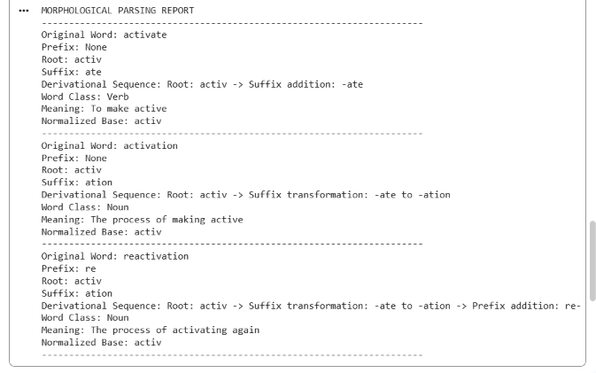

Morphological Analysis:
Word | Prefix | Root | Suffix | Word class
activate | None | activ | -ate | Verb
activation | None | activ | -ation | Noun
reactivation | re- | activ | -ation | Noun

Analysis of Derivational Changes:
- Prefix re-: Adds the meaning “again” or “repeat,” producing reactivation.
- Suffix -ate: Forms a verb, as in activate.
- Suffix -ation: Forms a noun describing an action or process, as in activation.
- Normalization: Maps all three words to the common lexical root activ for semantic grouping and indexing.
Result:
The Python program successfully performs rule-based morphological parsing, identifies prefixes, roots, and suffixes, explains derivational transformations, and maps activate, activation, and reactivation to a common normalized base representation for document classification.

Question 2
Inflectional Morphology-Based Normalization Using Python
Title:
Rule-Based Part of Speech Tagging, English Word Classes, Part of Speech Tagging
Aim:
To develop a Python program that identifies inflectional suffixes in the words “create”, “creates”, and “creating” and normalizes them to a common base form for efficient information retrieval.
Problem Statement:
Develop a Python program to implement an inflectional morphology-based normalization system for the words “create,” “creates,” and “creating.” The system should identify grammatical suffixes, extract root words using appropriate normalization rules, classify each word according to its grammatical form, and normalize all variations to a common base form to improve search optimization and information retrieval.

Explanation:
The program analyzes the words “create,” “creates,” and “creating” by identifying their inflectional suffixes and grammatical categories. It removes -s from “creates” and -ing from “creating,” applying spelling rules to recover the root create. All three words are normalized to the same base form without changing their core meaning. This improves search optimization by allowing documents containing different grammatical forms to be retrieved consistently.
Algorithm:
- Initialize the input words.
- Identify suffixes such as -s and -ing.
- Extract the root by applying appropriate spelling rules.
- Classify each word according to its grammatical category.
- Normalize all words to the base form create.
- Display the morphological analysis in a structured report.
Code:
words = ["create", "creates", "creating"]
def normalize_word(word):
suffix = "None"
category = "Base Form"
root = word
if word.endswith("ing"):
suffix = "-ing"
category = "Present Participle"
root = word[:-3] + "e"
elif word.endswith("s"):
suffix = "-s"
category = "Third-Person Singular"
root = word[:-1]
normalized = root
return {
"Original Word": word,
"Suffix": suffix,
"Grammatical Category": category,
"Extracted Root": root,
"Normalized Base": normalized,
"Final Representation": normalized
}
print("INFLECTIONAL MORPHOLOGY REPORT")
print("-" * 45)
for word in words:
result = normalize_word(word)
for key, value in result.items():
print(f"{key}: {value}")
print("-" * 45)
Output:
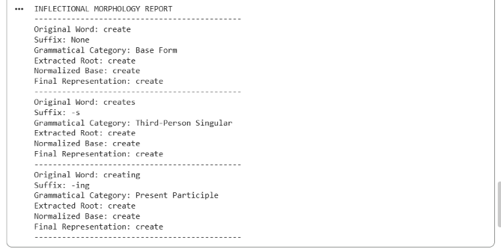

Morphological Breakdown:
Original Word | Root Word | Suffix | Grammatical Category | Normalized Form
create | create | None | Base form | create
creates | create | -s | Third-person singular | create
creating | create | -ing | Present participle | create

Result:
The program successfully identifies inflectional suffixes, classifies grammatical forms, extracts the root word, and normalizes all three words to create for efficient information retrieval.

